Based on the analysis of crime types and offender-victim relationships, we have gained insights into the overall distribution and frequency of various relationships in different crimes. We calculated and displayed the proportion of relationships such as "stranger" and "known to victim." Additionally, we conducted an analysis of different victim types within distinct crime relationships.

First, we performed an overall calculation on 10 years of data using R. From Figure 1, titled "Frequency Distribution of Rov," it is evident that the available data on the relationships between victims and offenders represents only a small portion of the total data provided by the police. As a result, we selected two key categories, "known to victim" and "stranger," for further analysis of crime types.

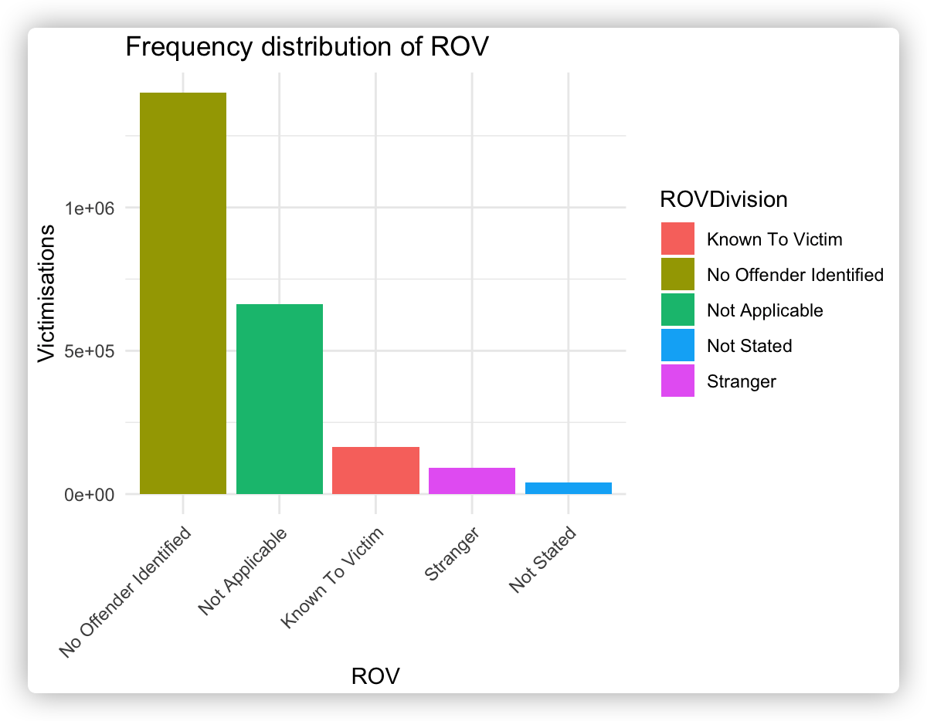

Figure 1

As shown in Figure 2, the crime type "Acts Intended to Cause Injury" mostly involves offenders who are known to the victim, which may suggest a high incidence of domestic violence. Therefore, the police should focus on improving interventions in domestic violence cases, particularly by providing support and protection for high-risk individuals.

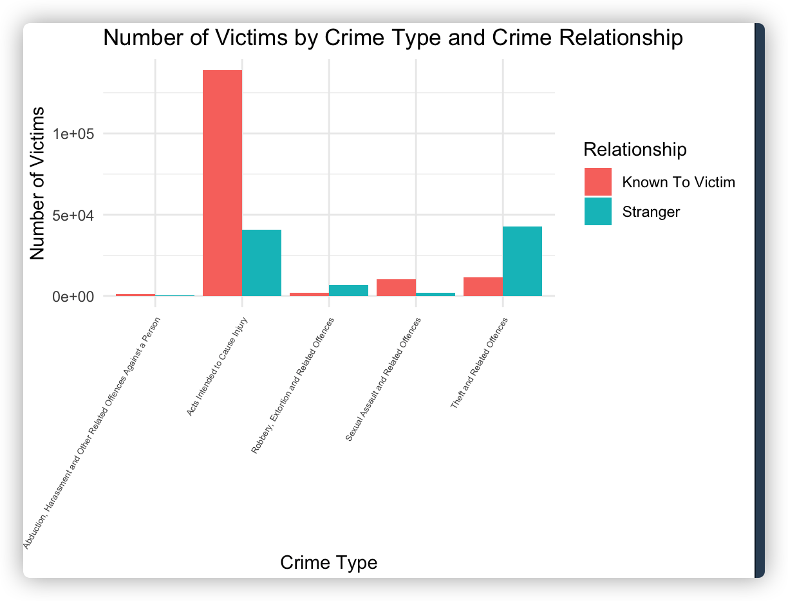

Figure 2

We also created a time series line chart in Tableau to observe changes in victim data over time. As shown in Figure 3, titled "Crime Forecast for the Next 12 Months," while there are noticeable fluctuations, the overall trend has been rising year by year, with a significant spike in crimes in 2021. This surge could be attributed to economic factors related to the COVID-19 pandemic.

For the crime forecast over the next 12 months, the number of victims is expected to fluctuate within a narrow range but remain consistently high. Given the projected elevated crime levels, the police department should consider reallocating resources, such as increasing police presence and surveillance in high-crime areas, to effectively reduce crime rates.

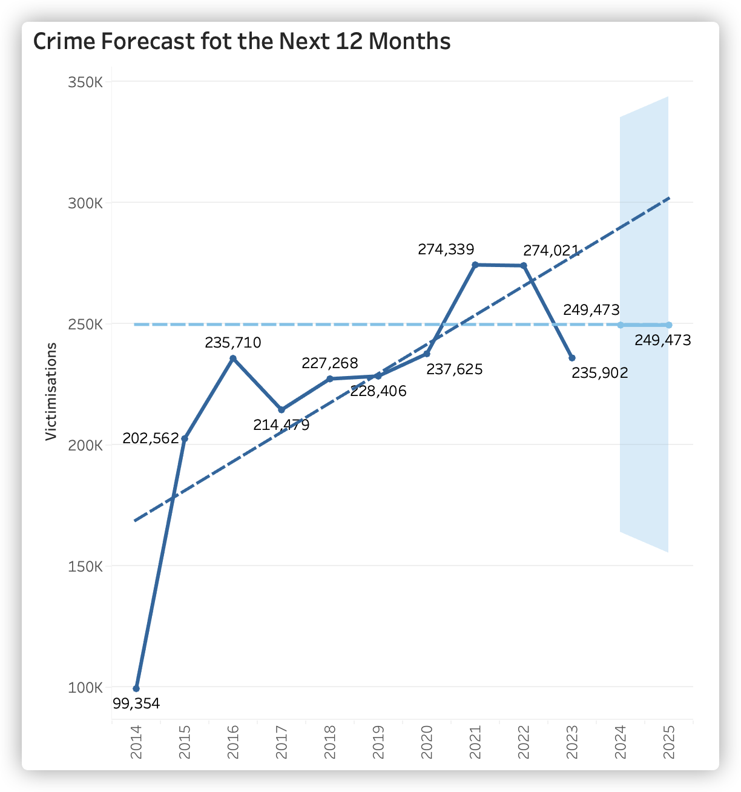

Figure 3

In conclusion, focusing on domestic violence prevention and strategically deploying resources in high-risk areas could be essential steps in mitigating future crime rates and ensuring the safety of vulnerable populations.